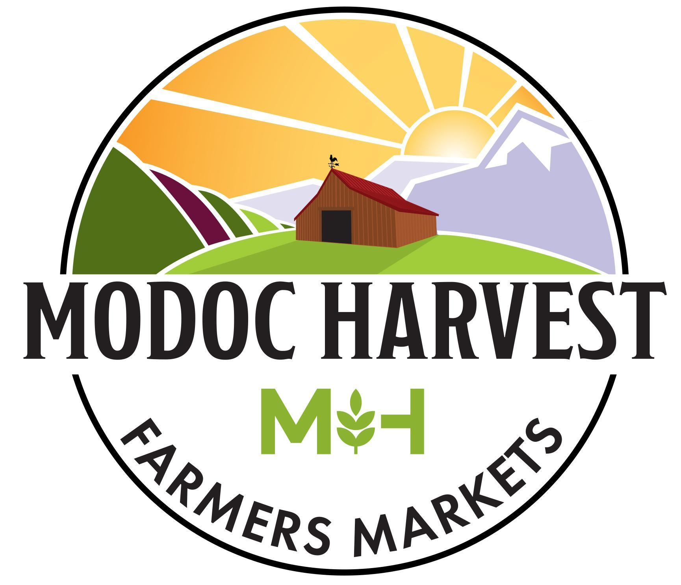
Modoc Certified Farmers Markets
Surprise Valley Farmers Market & Alturas Farmers Market

Rules and Regulations

A place where all members of the community can connect directly with local producers of healthy food and handcrafted goods while enjoying a morning with their neighbors

Why Certified Farmers Markets?
Up until 1977, California State regulations required farmers to use standard packing size and labeling for their fresh fruits, vegetables and nuts to transport and sell in markets. Due to these regulations, farmers did not have any direct-to-consumer marketing options other than selling on their own property. In 1977, Governor Brown signed an executive order allowing farmers to sell directly to the public and allowed exemptions from complying with regulations for size, packaging, and transportation standards for fresh fruits, vegetables and nuts.
The core mission of Certified Farmers Markets is to support California farmers and ranchers through direct marketing to the public. This requires producers to take responsibility for the decisions and activities involved in all phases of bringing an agricultural product to market. CFMs also provide a benefit to the consumer, allowing direct communication with the people producing their food. Consumers can ask producers directly about agricultural methods or practices that are personally important to them; likewise, producers can openly communicate practices that may or may not take place on their farm or ranch while also educating consumers on their production model. Furthermore, buying from a Certified Producer ensures consumers that they are buying directly from the person or family who grew or raised the product.
Certified Farmers Markets are “point of sale” locations for California agricultural products that are certified by the California Department of Food and Agriculture but also may include non-agricultural products, cottage foods, prepared foods, and arts. CFMs are authorized by each individual county’s Agricultural Commissioner and each CFM must abide by current state and county legislation and regulations in addition to their own individual market rules.
Modoc Certified Farmers Markets is a project of Modoc Harvest, a non-profit organization promoting local food education and access. The first Modoc Certified Farmers Market began in 2013 with the Surprise Valley Saturday Market in Cedarville. It has now expanded to include the Surprise Valley Saturday Market and the Alturas Farmers Market. The Modoc Harvest Modoc Certified Farmers Markets are the first and only Certified Farmers Markets in Modoc County.

General Rules
- All vendors must complete the Vendor Application Form and receive approval from market management before selling at MCFM. Market management reserves the right to select vendors based on their ability to enhance the market and fulfill our mission.
- Vendor set-up must be completed before the published opening time of the market and take-down is to be completed after the published closing time. Sellers may leave the market site prior to the published closing time only after receiving approval of the Market Manager who will assess public safety and welfare.
- Vendors are required to supply their own tables, chairs, shade canopies and other necessary equipment. Shade canopies must be tied down and secured in windy conditions.
- A bell will signify the opening and ending of the market. Please refrain from selling before the market officially opens.
- Vendors must display at least one sign with business name and location including county and city and a statement such as “ I/We grow/make what I sell, produce, raise, etc.” or a similar phrase.
- All prices must be clearly marked or posted.
- Vendors must provide copies of required certificates to the Market Manager and post copies at their stall before they will be allowed to sell at the Market.
- Vendors must complete a Load Sheet and give said sheet directly to market management along with daily vendor fees before leaving the market grounds.
- Vendors must meet county guidelines for sample procedures.
- Vendors must maintain clean, sanitary booth space and are responsible for removing their trash, and any trash generated from their products, from the site at the end of the market day.
- All food and food boxes must be kept at least 6 inches off the ground or food may be secured in an ice chest.
- No animals, other than service animals, are allowed within 20 feet of any food vendor.
- Tobacco products are not permitted within 25 feet of the market area.
- Vendors are strongly encouraged to obtain general liability and product liability insurance. MCFM has farmers market insurance but this does NOT cover individual vendors.

Vendor Fees
- Season fees are due at the beginning of the season: $150 for the season to sell at SVSM and AFM, $100 to sell at SVSM OR AFM.
- Daily Market Fees are due at the close of each market: $20 flat fee OR 10% of sales per market - whichever is lowest.
- All fees are per vendor and not per booth space. All vendors, even if sharing booth space, must pay an individual vendor fee.
- Vendors may pay with cash or check made out to Modoc Certified Farmers Markets

Required Certificates/Permits and Regulations (by Vendor Type)

A. Producers: Certified Agricultural Products
(Fresh fruits, nuts, vegetables, shell eggs, honey, flowers, nursery stock)
- Must have a Certified Producer’s Certificate as of 2020 this can be submitted online here . A supplement is available for a large number of products. If not completing online, submit completed Certificate to Modoc County Ag Commissioner: 202 West 4th Street, Alturas, CA 96101, (530) 233-6401, agcommissioner@co.modoc.ca.us .
- All scales used in the Market must have current valid inspection seals from the seller’s County Sealer of Weights and Measures. The Market will provide two certified scales to be shared by all Vendors.
- Sealed bags or containers must have an IRQ label stating Identity (What it is), Responsible Party (Name, address, and zip code of producer), Quantity (count, weight, volume)
- If selling other products in addition to certified agricultural products, those products must be separated on your table(s) and noted with a sign indicating the certified agricultural products
- Certified Agricultural Producers may sell products for another Certified Producer if they are listed on each other’s Certified Producers Certificates.
- If selling eggs, must have an Egg Handlers License in addition to Certified Producer’s Certificate
- If selling plants, must have a Nursery Stock License in addition to Certified Producer’s Certificate. You can obtain a Fee Exempt License if your sales of plants will amount to less than $1000 in 12 months.

B. Livestock meat, poultry, and rabbits
- Livestock meat must be processed in a USDA inspected slaughter facility and be labeled as such. Poultry and rabbits raised on your farm may be slaughtered on your premises and are exempt from state laws (limited to 1000 animals per year or less). Poultry and rabbits may only be sold directly to household consumers. They cannot be sold to restaurants, grocery stores, etc.
- Meat for sale must be kept frozen.

C. Cottage Food Operators: Non-Agricultural Food Products
(Baked goods, candy, dried fruit, dried pasta, dry baking mixes, fruit pies, granola and cereals, jams and jellies, nut butters, popcorn, vinegar and mustard)
- Must have current Modoc County Cottage Food Application Packet
- Must comply with labeling requirements for Cottage Food
- Questions: Modoc County Environmental Health (530) 233-6310, enviro@co.modoc.ca.us

D. Prepared Food
(Food vendors)
- Must have an approved Temporary Food Facility Permit
- Must follow sanitary requirements outlined in Modoc County Community Event Vendor Packet
- Submit Application to Warren Farnam, Modoc County Director of Environmental Health: 202 West 4th Street, Alturas, CA 96101, (530) 233-6310, enviro@co.modoc.ca.us

E. Artisans: Non-Food Products
(Arts and crafts)
- Must be handcrafted locally by vendor or vendor’s family. Modoc CFMs are not a venue for resale items.
- All producers selling taxable items must certify on their Vendor Application that they are registered with the California State Board of Equalization, that they agree to bear full responsibility for the proper collection and reporting of sales taxes, that they agree to protect and defend Modoc Harvest and its farmer’s markets in case of any dispute with the State Board of Equalization, and provide a copy of their Seller's Permit to Modoc Certified Farmers Market.

F. Community Groups
- Community groups must fill out an application and receive approval from market management.
- Community groups are subject to all market rules and regulations.

Contact us:

Surprise Valley Farmers Market  Market Manager: Jenny Kapp  sfm@modocharvest.org  530-936-7876 | Alturas Farmers Market  Market Manager: Anne Mileck  afm@modocharvest.org  530-936-7876

ModocHarvest.org

Modoc Harvest
PO Box 549
Cedarville, CA 96104

